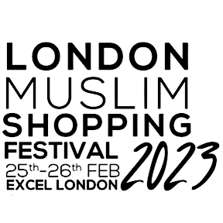

Sampling/Selling of Food and/or Drink Permission Form
You must complete and return this form if you are undertaking any of the above activities, please return to: info@maelstromeventsolutions.co.uk
Company Name:
Stand No:
Contact Name:
Email address:
Are you sampling or selling food?

Sampling
Selling
Both

Are you sampling or selling drinks?

Sampling
Selling
Both

Does anything you are selling/sampling contain alcohol? If so, give details below:

I intend to sell/sample food and/or drink at the event (select Y/N where required) at the London Muslim Shopping Festival 2023 and attach the following in your email:
- Local Authority Registration Certificate as food business Y/N
- HACCP (full food/drink safety system) Y/N
- Food Hygiene Certificate – Minimum Level 2 Y/N
- Risk Assessment Y/N
- Method Statement Y/N

I confirm that all my products have a full list of ingredients clearly available in English and allergen information is clearly displayed.

Signed:

Print Name:

